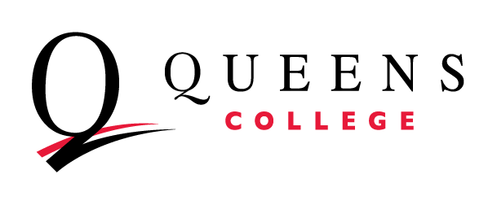
2025 Assessment Overview Survey

Department / Program:

The 2025 Assessment Overview Survey has three parts: Program Learning Objectives, the Self-Assessment Rubric, and Professional Development Requests.

Program Learning Objectives:
In the chart below, list each degree program your department or program offers in the left-hand column. (If you have multiple concentrations or tracks in your degree program, you can decide whether to list each one separately or group them together.) Then list the Program Learning Objectives that your department has approved for that degree program in the right-hand column. Add or delete rows as necessary to incorporate all your degree programs.

Degree Program | Program Learning Objectives
PLO 1.
PLO 2.
PLO 3.
PLO 4.
PLO 1.
PLO 2.
PLO 3.
PLO 4.
PLO 1.
PLO 2.
PLO 3.
PLO 4.
PLO 1.
PLO 2.
PLO 3.
PLO 4.

Self-Assessment Rubric:
We are collecting updates on your department’s progress towards a strong foundation for sustainable assessment practice. Mark one category per row about the current state of assessment practice in your department.

Capacity Criteria | Developed | Emerging | Needs Work
Course Learning Objectives in place | □ All courses offered by the department include course learning objectives that are student-centered, observable and aligned with assignments. | □ All courses offered by the department include course learning objectives, but not all are student-centered, observable and aligned with assignments. | □ Not all departmental courses have student learning objectives.
Program Learning Objectives in place | □ Each departmental program has program learning objectives that are student-centered, observable and aligned with courses. | □ Each program has learning objectives, but not all are student-centered, observable and aligned with courses. | □ Not all departmental programs have overall learning outcomes.
Curriculum Map in place | □ The department clearly aligns curricular offerings to program-specific learning objectives. | □ The department ties curricular offerings to levels of learning, but not yet to program-specific learning objectives. | □ The department does not yet explicitly tie curricular offerings to program learning objectives.
Assessment Methods in place | □ The department has developed assessment methods that effectively convey information about how well students are meeting learning outcomes, about program support for students and DEI, and alumni outcomes. | □ The department has developed program assessment methods, but they do not yet follow best practices. | □ The department has not yet developed methods to assess student learning or support.

Professional Development Requests:
We are collecting ideas about the kind of professional development that you would like to see offered by the Office of Institutional Effectiveness and the Academic Assessment Council. What topics would you like to see covered in an in-person workshop or supported through online videos?

