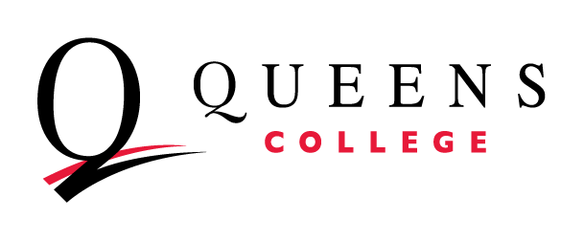
Mission Statement Worksheet

Use this document to craft a mission statement. A mission statement is a general statement that briefly outlines the overall purpose of a department/unit at the college. Mission statements should be stable over time, only changing in the event of fundamental changes to the role or purpose of the department.

- Purpose | - Stakeholders | - Relationships | - Student Exp | - Student Success
What does your department do? Try to list and describe its main functions and purpose. | Who does the department do this for (e.g. staff, students, faculty, etc.)? | What relationships does the department have with other units at the college? | Does the department directly affect the student experience? If yes, how so? | How does the department contribute to student success?
Using the above, craft a clear and succinct mission statement below. Try beginning with, “The mission of…is to…by…”.

Need examples? Below are a few mission statements of actual QC departments.

Office of Academic Affairs
The mission of the Office of Academic Affairs is to promote an exceptional and accessible culture of academic excellence that prepares a diverse student body for successful careers, advanced studies, service, and leadership in their communities while fostering creativity, innovation in teaching, learning, creative arts and research.

Graduate School of Library and Information Sciences
GSLIS is committed to providing affordable programs and rigorous teaching to educate critically-minded, community-focused, and service-oriented professionals who will contribute to diverse information-intensive environments, the vitality of their local and global communities and the advancement of the LIS disciplines, research, and practice.

Academic Advising Center
The Academic Advising Center (AAC) at Queens College provides centralized and integrated academic advising to incoming and current undergraduate students through the articulation, clarification and navigation of degree requirements in order to foster timely and successful completion of the baccalaureate degree. The center serves as a bridge between the college and the student body by ensuring clarity, uniformity and accessibility of academic requirements and policy and procedural information.

Office of Institutional Effectiveness
The Office of Institutional Effectiveness (OIE) supports the evidence-based decision-making administrators, faculty, and staff by providing high quality and trustworthy data to inform student success initiatives, program development and evaluation, grants, public relations, and strategic planning, and to help meet compliance reporting requirements. Through collaboration with academic and administrative departments across the college, the OIE aims to support a culture of inquiry, evidence, and innovation at Queens College.

Queens College
The mission of Queens College is to prepare students to serve as innovative leaders in a diverse world that they make more equitable and inclusive. We do this by recognizing every student’s potential and facilitating opportunities to achieve it. We guide students to determine their desired paths forward that are in service to the ways they define their community or communities. We prepare undergraduate and graduate students through rigorous academics and provide support so that students are able to complete their courses of study and find the right path after graduation. We take an aspirational yet practical approach to liberal arts and professional education: engaging students in learning, knowledge creation, and cocurricular activities that broaden their minds while giving them tangible skills to succeed in careers and life.

