

Every Semester Needs a Plan
Step #1: Identify Your Goals

(5 Minutes)

Research/Writing Goals:

1._______________________________________

2._______________________________________

3._______________________________________

Personal Goals:

1._______________________________________

2._______________________________________

3._______________________________________

Step #2: Map out the steps

(it’s your turn!)
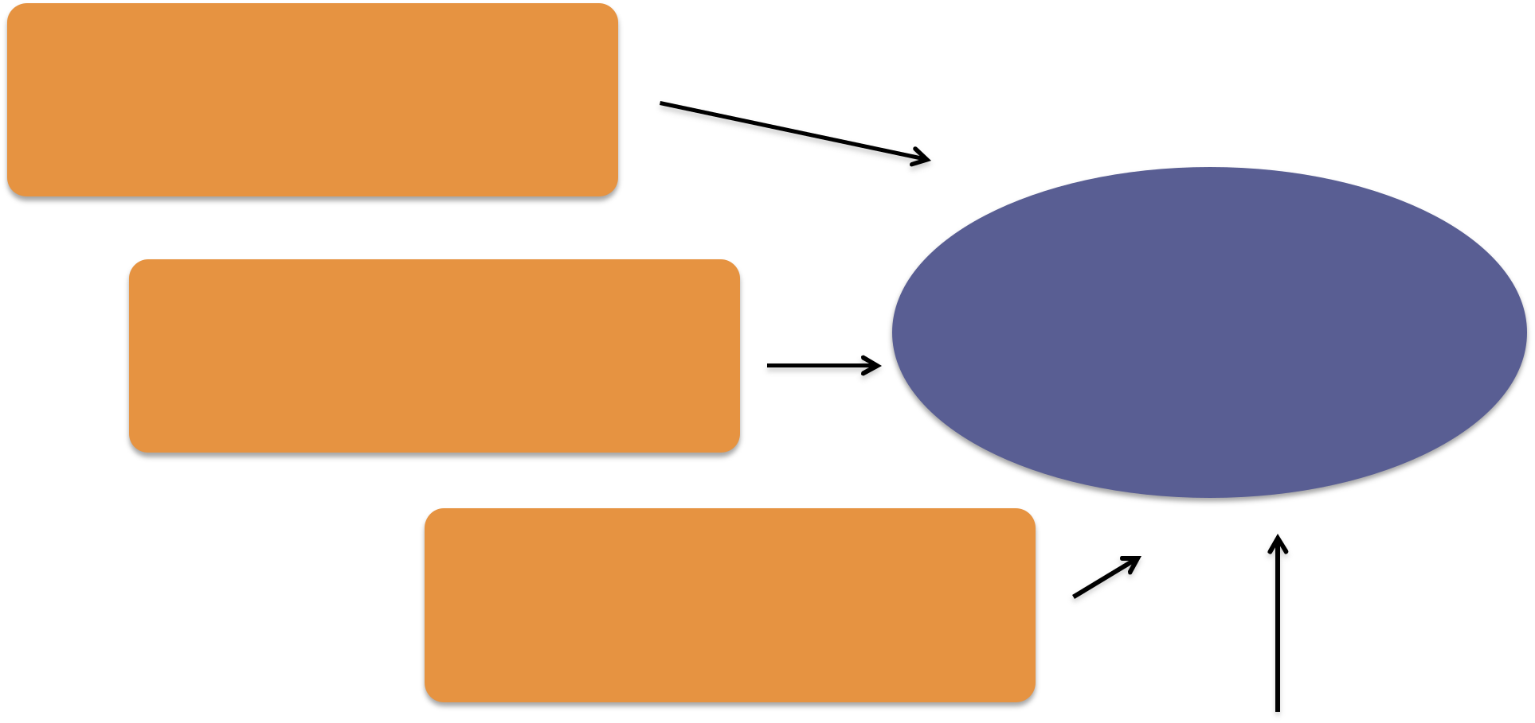

GOAL

Step #2: Map out the steps

(it’s your turn!)

GOAL
Step #2: Map out the steps

(it’s your turn!)

GOAL
Step #3: Introduce your PROJECTS to your calendar (example)

MONTH | WEEK | WRITING/RESEARCH | PERSONAL
 | Week 1
 | Week 2
 | Week 3
 | Week 4
 | Week 5
Step #3: Introduce your PROJECTS to your calendar (example)

MONTH | WEEK | WRITING/RESEARCH | PERSONAL
 | Week 6
 | Week 7
 | Week 8
 | Week 9
 | Week 10
Step #3: Introduce your PROJECTS to your calendar (example)

MONTH | WEEK | WRITING/RESEARCH | PERSONAL
 | Week 11
 | Week 12
 | Week 13
 | Week 14
 | Week 15

