Monthly chart: on the long term, it seems that the ETF cocoa encounters some resistance. There is support at 27 that became a resistance, then the upward trendline and the 50 month moving average. Even if there is some attempt to break the downward trendline, it may be difficult to see an upward move, except if there is fundament great change in supply and demand.

The momentum indicators don’t show anything.

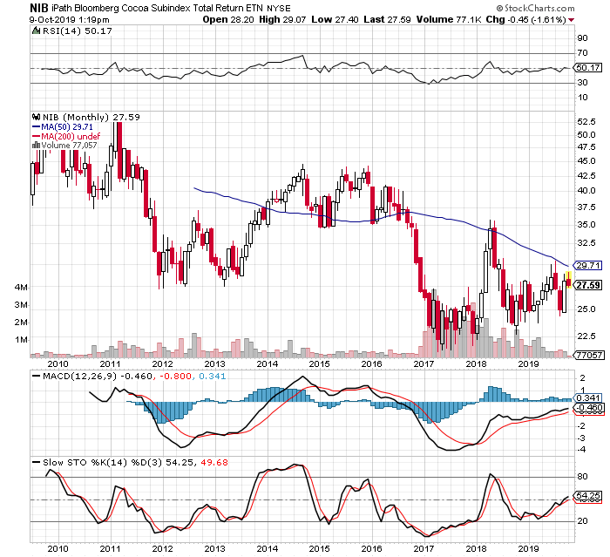

Weekly chart: on the medium term, it seems also that it would be difficult to overcome the different resistance: 200 week moving average, from the gap that took place beginning of 2018, the upward trendline.

Again, the momentum indicators don’t show anything.

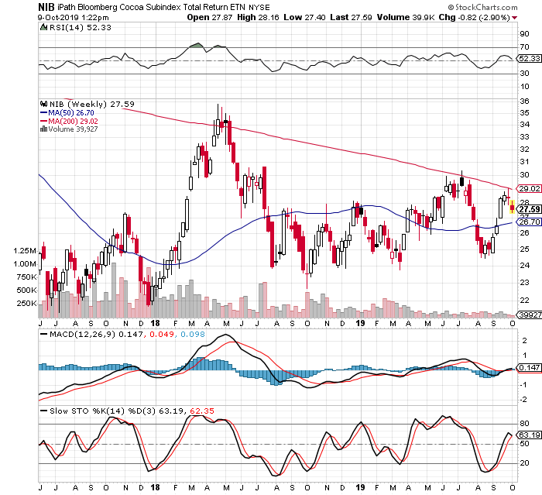

Daily chart: on the short term, the ETF is breaking down some patterns. It would have been great to short it last week as the momentum indicators RSI, MACD and STO indicated that it was overbought. It broke two days ago the small broadening formation on the downside so the ETF may continue to go down.

Be careful, don’t chase the security… if you missed it, you missed it!

