For manufacturing, we can use ETF Industrial such as XLI.

On the daily chart, the ETF is between an obvious support and resistance, but the 200 day moving average is also a support.

The RSI doesn’t provide a strong signal. MACD is better but not very strong either. STO is indicating a buy signal. However, remember that RSI is slower than MACD which is slower than STO. So STO has more false signals, or sometimes to have to wait longer.

Daily 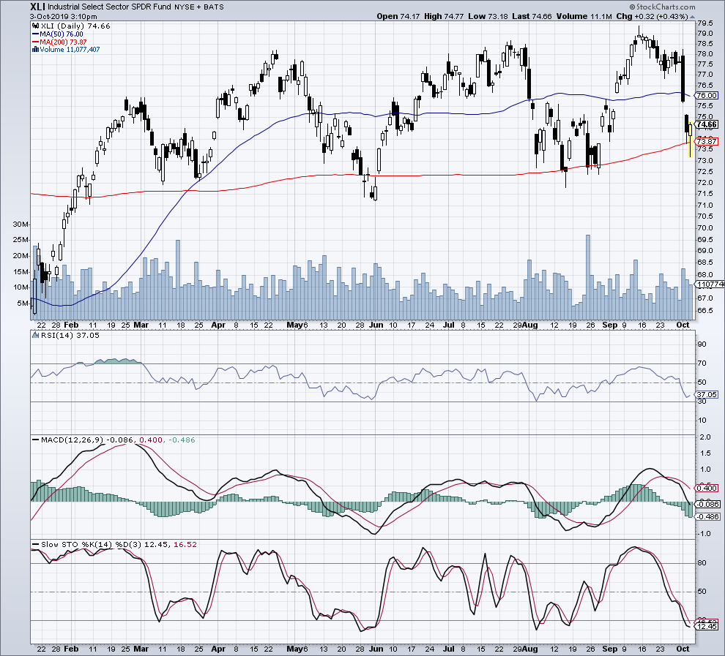

On the weekly chart the momentum indicators don’t give you neither a buy signal nor a sell signal.

We can see that there is a strong resistance at 78, since the beginning of 2018.

Weekly

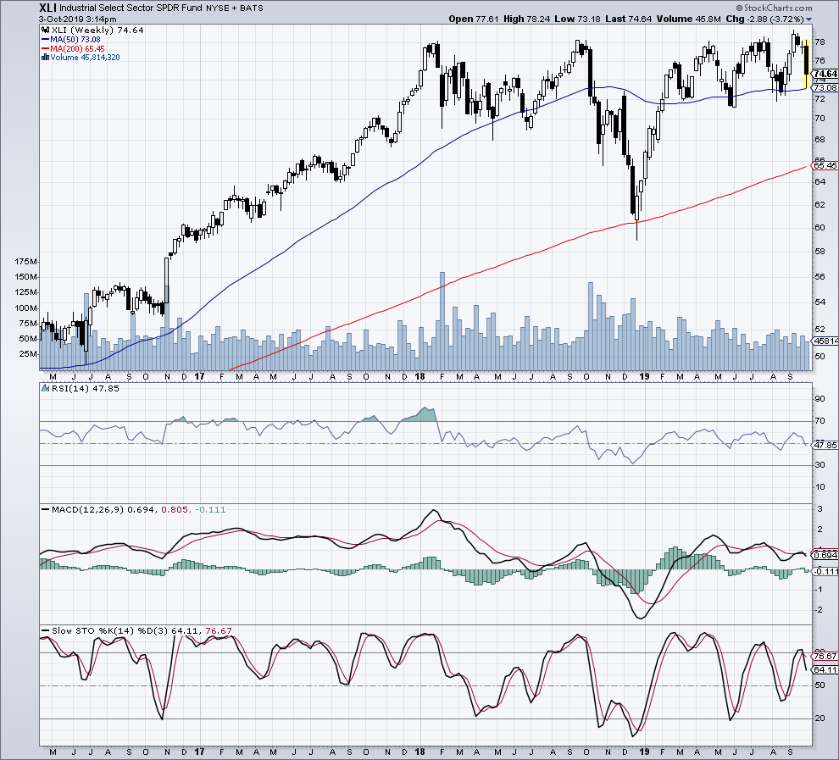

On the monthly chart we can see that the industry, but also the SP500 or DOW Jones (they seem to follow the same path as industrials) are on the side line since the beginning of 2018. The longer is the battle between buyers and sellers, the stronger will probably be when it breaks out, on either side.

Monthly

