Monthly chart: the euro is dropping since 2009, and seems to continue to go down slowly from the beginning of 2018. There will be a strong support somewhere between 101 and 102.5 and from the downward trendline.

The momentum indicators don’t show much. The STO shows that it is oversold but it is more subject to false signals than the others.

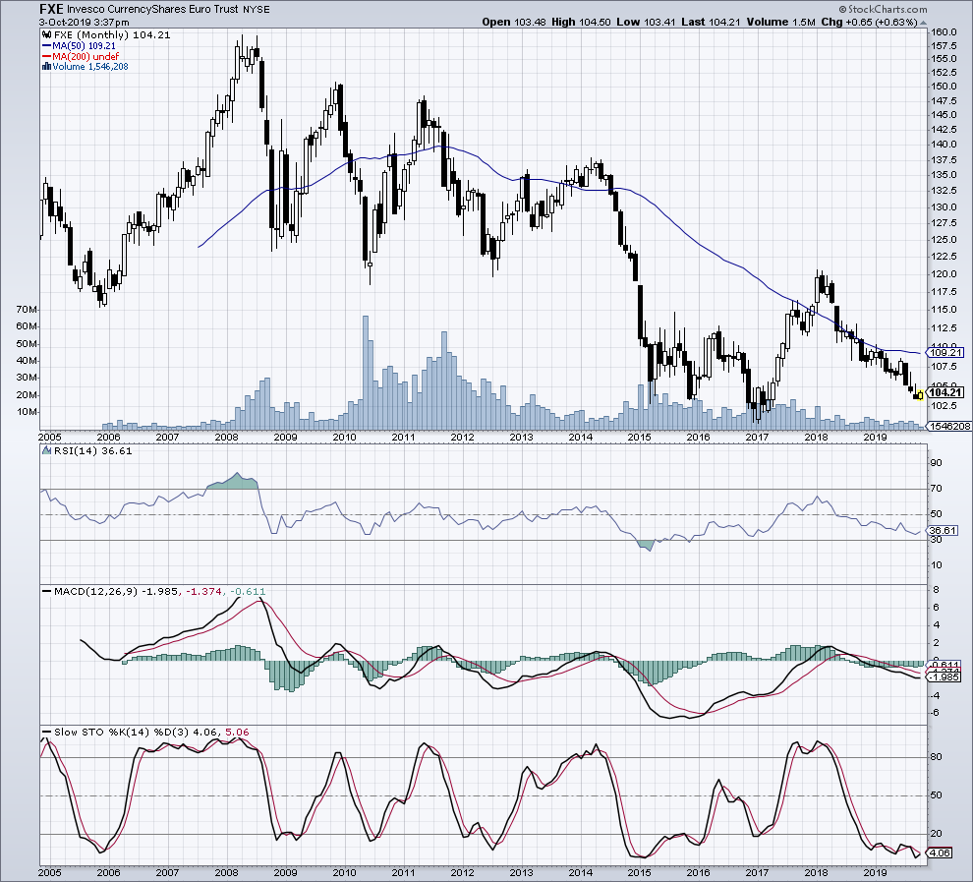

Weekly chart: on the medium term, we have the same outlook; it seems to go down slowly but surely.

Again, the signal from STO may be a false signal. More exactly, we cannot buy just beacause of it.

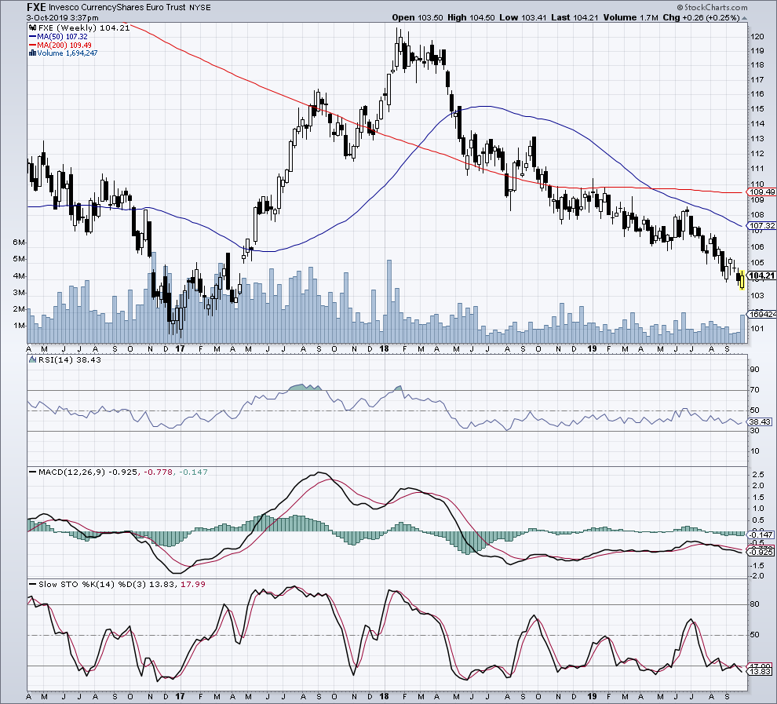

Daily chart: the short term shows also the slow decline of the euro.

It reached here a resistance from a trendline.

Again, the buy signal from STO is not enough to buy.

